A 517 THz laser beam passes from a prism and is refracted as shown in figure below.

Calculate its starting wavelength in said medium.

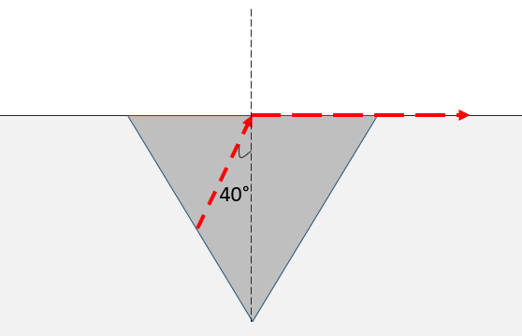

air n=1.00